“My Life’s Soundtrack” Project

Your task is to create a playlist that could form the “soundtrack” to your life. You will analyze the lyrics to each song and identify examples of figurative language and poetic devices. The songs may be in any language, but your analysis must be in English.
Below is a suggested organizational structure. The songs do not have to actually come from the time period you’re associating them with.
Track 1: Early childhood. Choose a song that makes you think about your earliest memories, the place where you were born, etc.
Track 2: Elementary school. Choose a song that makes you think about the events and changes you experienced as you transitioned from infancy to “big kid” status.
Track 3: Middle school. Choose a song that reminds you of the awkward struggle and the challenges you faced as a “tween.”
Track 4: High school/present day. You may want to eliminate one of the previous 3 options to choose two for this phase of your life; maybe one that reminds you of your teen years in general, and another that is lockdown/quarantine-specific.
Track 5: Future. Choose a song that makes you think of your hopes, fears, dreams, and/or plans for the future.
For each track, complete the following:
- Title, artist, and genre (5 points)
- An explanation/description of the song (5 sentences; 30 points):
  - Why did you choose the song?
  - What is it about?
  - Why does it remind you of this particular phase of your life?
- At least one example of figurative language from the song with an explanation of its purpose and/or effect (10 points). A list of these literary devices with definitions and examples can be found on the following page.
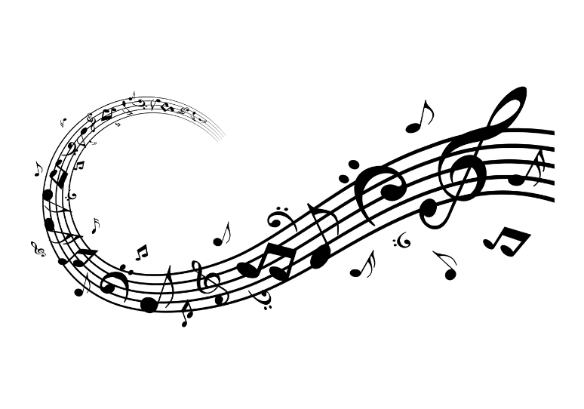
In addition, you will create an “album cover” for your soundtrack, either by hand or using the software of your choice (5 points). If you use PowerPoint or Prezi to create your project, each track should have its own slide and include an appropriate visual. Feel free to embed audio or include YouTube links for each song as well.

Figurative Language
Figurative language is a tool that an author uses to help the reader visualize, or see, what is happening in a story or poem.
Types of Figurative Language
Simile is a comparison using “like” or “as.” It usually compares two unlike objects.
Example: “His feet are as big as boats.” Feet and boats are being compared.
Metaphor states that one thing is something else. It is a comparison, but does NOT use “like” or “as” to make the comparison.
Example: “You are my sunshine.”
Personification is giving human qualities, feelings, actions, or characteristics to inanimate (not living) objects.
Example: “The house stared at me with looming eyes.” The verb, stared, is a human action. A house is a nonliving object. Therefore, we have a good example of personification.
Alliteration is the repetition of the initial consonant sound. There should be at least two repetitions in a row.
Example: “Peter Piper picked a peck of pickled peppers.” The first letter, p, is a consonant. Its sound is repeated many times.
Onomatopoeia is the imitation of natural sounds in word form. These words help us form mental pictures, or visualize, things, people, or places that are described. Sometimes a word names a thing or action by copying the sound.
Example: “Bang! Hiss! Buzz!”
Symbolism occurs when one thing stands for or represents something else.
Example: The use of a dove to symbolize peace or a heart to represent love.
Hyperbole is exaggeration used for emphasis.
Example: “I’m so hungry I could eat a horse!”
Imagery involves one or more of your five senses – the abilities to hear, taste, touch, smell, and see. An author uses a word or phrase to stimulate your memory of those senses and to help create mental pictures.

